Suryanarayan.B

CB.EN.U4CSE19056

1) AREA program, CODE, READONLY

LDR R1,=data

MOV R3,#10

LDR R4,choice

MOV R5,#0

MOV R6,#1

loop

LDR R2,[R1],#4

AND R6,R2,#1;

CMP R6,#1

ADD R5,R5,R2;

SUBS R3,R3,#1;

CMP R3,#0

BNE loop;

Stop

B Stop

data DCD 1,2,3,4,5,6,7,8,9,10

choice DCD 1

END

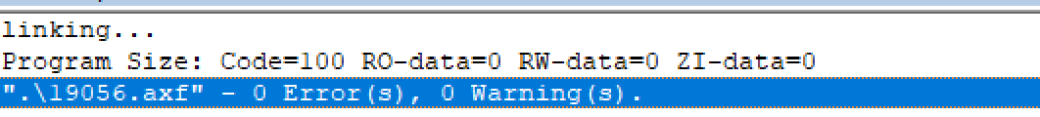

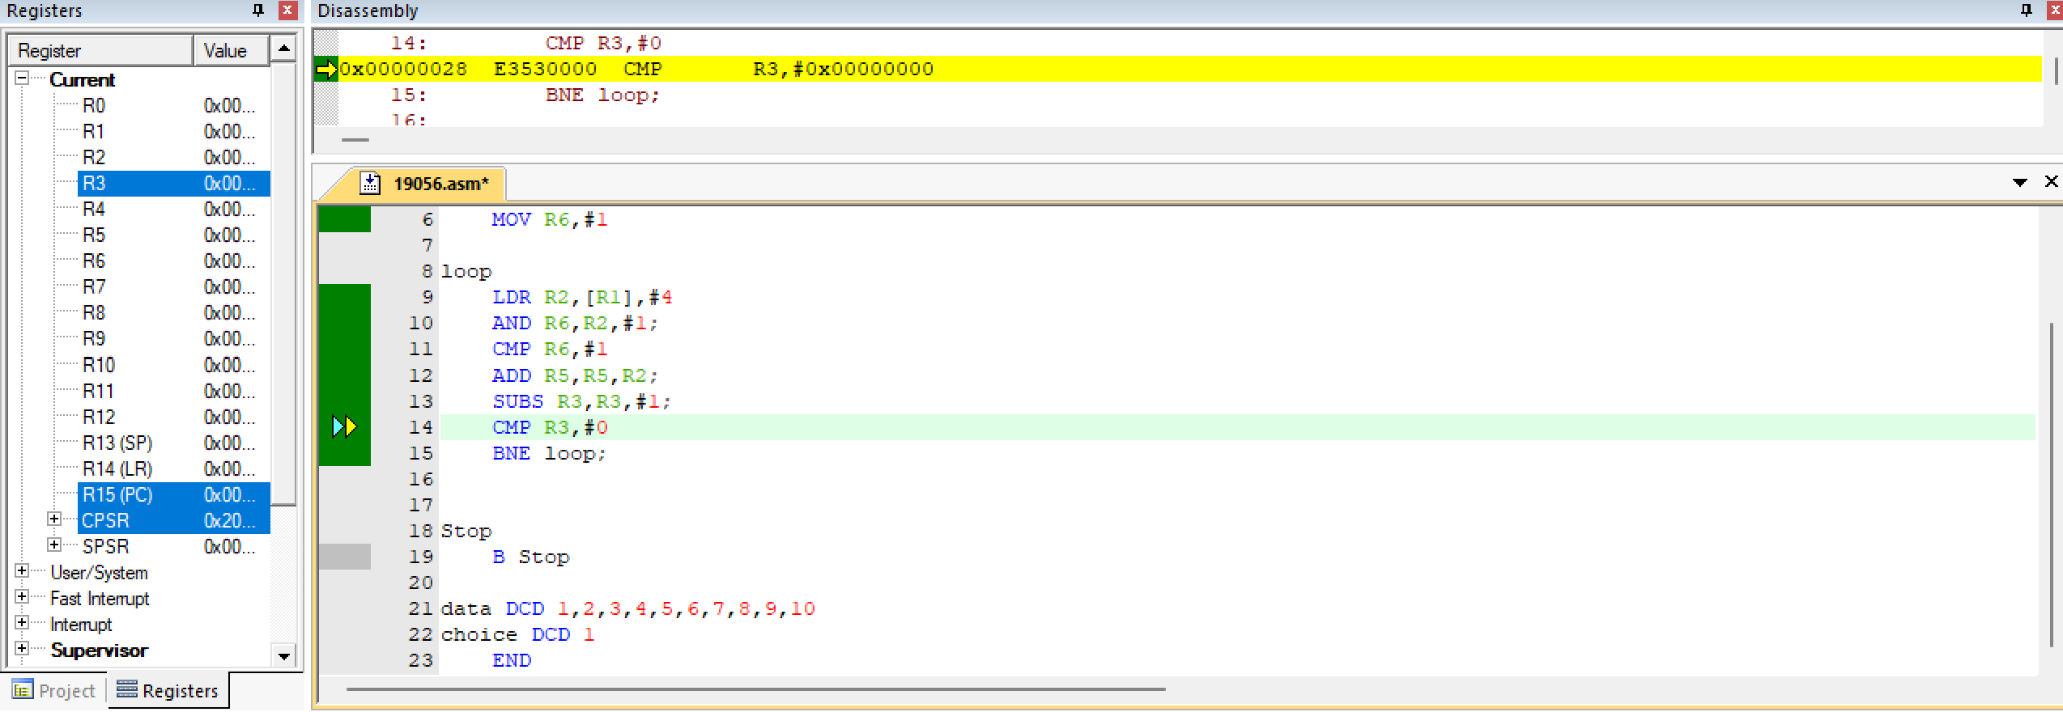

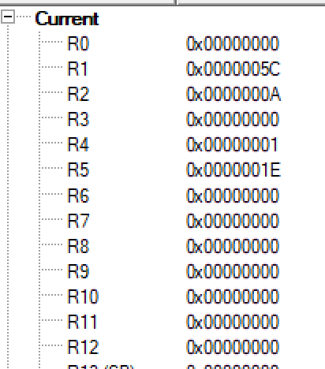

Ans=R5=30